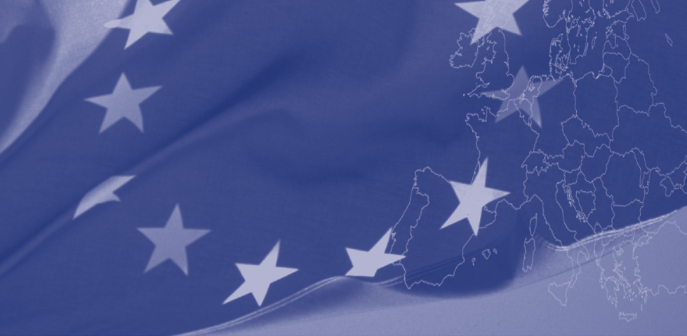 

**For more information**

**Addressing Negative Economic and Social Consequences of Labour Migration Through the Enhancement of Protection Services of Families and Children of Migrants Left Behind in Tajikistan**

The European Union’s EuropeAid programme

for the Republic of Tajikistan

**Delegation of the European Union**

**To the Republic of Tajikistan**

Address: 74 Adhamov Street

734013 Dushanbe, Republic of Tajikistan

Tel. (+992 37) 221 74 07, 227 10 24

Fax. (+992 37) 221 43 21

Web site: [Delegation-Tajikistan-Pic@eeas.europa.eu](mailto:Delegation-Tajikistan-Pic@eeas.europa.eu)

<http://eeas.europa.eu/delegations/tajikistan/index_en.htm>

**Save the Children International**

Address : 56 S. Nosiri Street, Dushanbe

Tel. +992 37 224 77 68

Web site : www.savethechildren.net

**International Organization for Migration**

Address: #22A, Vtoroy proezd Azizbekov Street,

734025 Dushanbe, Republic of Tajikistan

Tel. (+992 37) 221-03-02 / 224-71-96

Web site: [www.iom.int](http://www.iom.int)

The European Union is made up of 28 Member States who have decided to gradually link together their know-how, resources and destinies. Together, during a period of enlargement of 50 years, they have built a zone of stability, democracy and sustainable development whilst maintaining cultural diversity, tolerance and individual freedoms. The European Union is committed to sharing its achievements and its values with countries and peoples beyond its borders. To this end the EU is active in Tajikistan since 1992 and provides approximately EUR 25 million annually in development assistance.

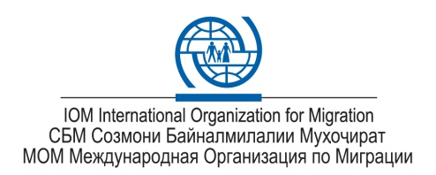

**"This publication has been produced with the assistance of the European**

**Union. The contents of this publication are the sole responsibility of *Save the Children International and International Organization of Migration* and can in no way be taken to reflect the views of the European Union."**

A project implemented by

Save the Children International and International Organization for Migration



This project is funded by

The European Union





**The Project will achieve its concept objectives through the following Key Actions:**

* Action-based Research on the situation of children from migrant families
* Capacity Building for Government officials, civil society NGOs, the communities and children
* Evaluation and development of referral mechanisms of child protection services
* Income generating and economic strengthening
* Raise awareness on the issues concerning the children of migrants

The Project will address the vulnerability of children from migrant families through tailor-made responses based on the results of the Action Research on the situation of children and their families and identification of the most vulnerable households.

By building the capacity of governmental and Non-State Actors who work within the child protection and social services structures, the Project will further enable the system to provide effective and child-centered responses to the needs and constraints of children and families affected by migration.

Improving the service provision systems and referral systems will support those caring for children left behind and will raise the awareness of duty bearers, service providers and families with regard to a protective package for such children.

**Target areas and groups**

The project activities will be mostly implemented in Khatlon Region (Kulyab, Kurgan-Tyube), Sughd Region (Khujand, Ayni) and Direct Rule District Region (Hissor and Tajikabad).

Children of Migrant families will be reached through the Migration Support Centres, Commissions on Child Rights, local NGOs and governmental Migration Services.

Enim vulputpat. Ut prat. Dui tet augiamet ver sisi blan ut in hent vel et in hendiatum dolor ipsusto consequat acillan dipsum ercidunt dolessi.

The Child Protection Situation Analysis conducted by Save the Children in October 2011 indicated that migration increases the vulnerability of children, especially of children from the poorest households or whose parents have decided to abandon their families in Tajikistan and start a new family abroad.

After parents migrate, children are much more likely to live in female-headed or child-headed households, with extended family members or be sent to residential institutions. The situation analysis survey has also highlighted the increased exposure to abuse and neglect suffered by children within their own families, communities and institutions.

A study conducted by UNICEF in November 2011 has also highlighted that children from abandoned families performed less well in school and were more likely to work in the household, small trade or in the field rather than attend non-compulsory education.

Additionally, children from migrant families showed a tendency to become withdrawn and depressed. Children were also more likely to become aggressive or rebellious, which was exacerbated by bullying at school.

**Addressing Negative Economic and Social Consequences of Labour Migration Through the Enhancement of Protection Services of Families and Children of Migrants Left Behind in Tajikistan**

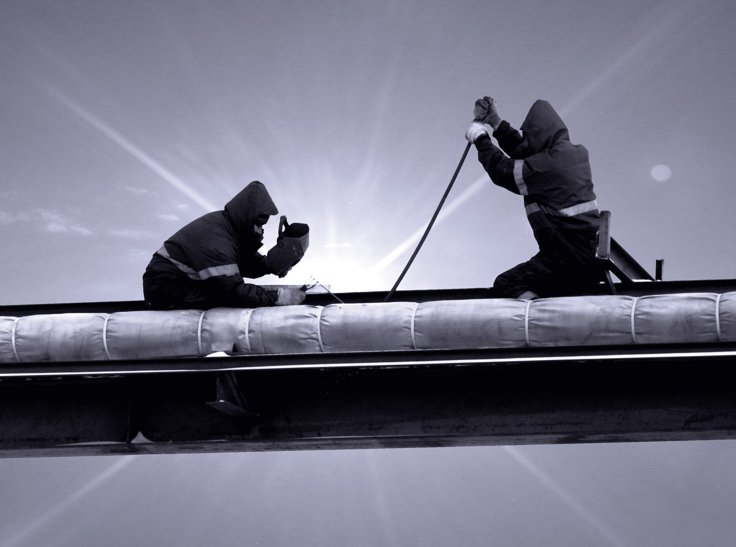

**Project Key Actions**

**The relevancy**

**The project approach**